Laboratory experiment Date: _________________
Gellan hydrogels for wound care - manufacturing and testing
Team names:

______________________________ _______________________________

______________________________ _______________________________
Manufacturing Process:
Step 1: Weigh out 2.5g of cotton or shredded wheat or your choice of fiber. If you are using cotton balls, pull the cotton fibers apart to make well dispersed fiber fluff. In the end, this will make a composite with 20% fiber by weight of gellan.
Step 2: Bring 500mL of water to a rolling boil in the 1L pan. BE CAREFUL!!!
Step 3: Pour boiling water into blender with at least a 1L capacity. Immediately add 12.5g or 4.5 teaspoons of gellan gum powder. This will create a ~2.5% solution.
Step 4: Blend on high for 20-25 seconds. IMPORTANT!!!: If the blender container is sealed, crack the lid every ~5 seconds to allow pressure to escape.
Step 5: Pour ½ of the solution back into the 1L pan and use the other half to fill 2 molds (about ¾ height).
Step 6: Add the fiber to the pan and stir while boiling the solution. Stir for about a minute until the cotton fibers are fully mixed in the solution. The gellan may form a film on the stir but you can scrape off and add the gellan back into the pan as it will dissolve again.
Step 7: Fill the remaining 2 molds with gellan solution (about ¾ height). It may be a bit lumpy but that is ok!
Step 8: Allow to cool (can be overnight or in a refrigerator).
Data:
Measure dimensions of your mold: length (mm) and width (w) (these are the length and width of your samples) then measure the thickness (t) of your samples (if the top is not flat, take an average of the edge and the center). Then weigh your samples (W) and calculate density (D) were D = W/l×w×t.
Sample | Length  (l, mm) | Width  (w, mm) | Thickness  (t, mm) | Weight  (W, g) | Density  (D, g/mm³)
1
2
3
4
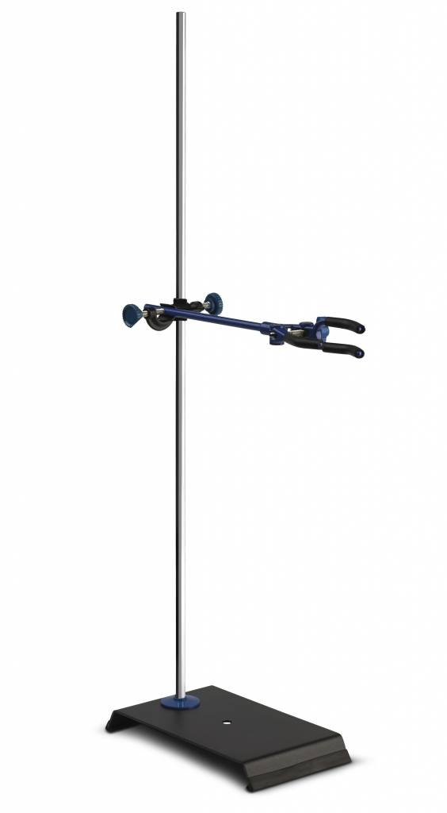
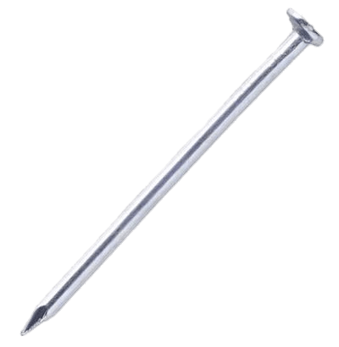
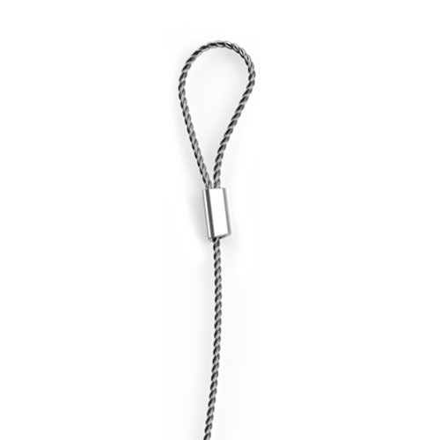
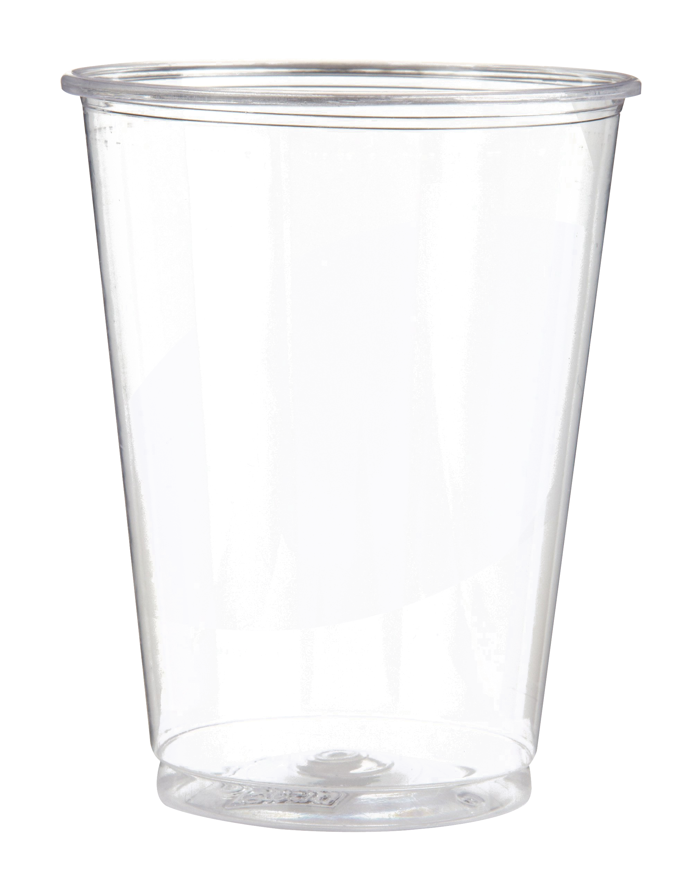
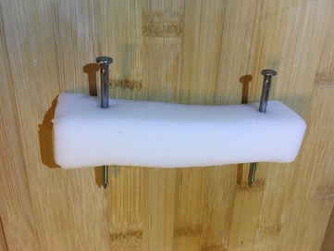
Hydrogel sample with nails inserted
Testing Process:
Step 1: Weigh the empty cup (We) and attached wire. Record value below.
Step 2: Measure the diameter of the nail or other object used to support the sample. Record the value below.
Step 3: Insert nail into sample ~1” from the end. See figure at right.
Step 4: Assemble the test fixture as shown at right.
Step 5: Pour 1/8 cup of rice into the cup and wait 20 seconds to see if the sample can support the weight. If it can, add another 1/8 cup of rice and wait another 20 seconds. Continue until the sample breaks. When the sample breaks, remove the last 1/8 cup of rice.

Step 7: Weigh the cup filled with rice (Wf) and subtract the weight of the empty cup (We) and wire. This is the maximum supported weight (Wmax). Record the values on the worksheet.
Step 8: Calculate the maximum shear stress Smax = Wmax/DN×t (g/mm²). To convert this value to Pascals (Pa) multiply by 9806.
Step 9: Do this measurement and calculation for all samples and complete the worksheet.
Step 10: Analyze the data and discus!
Data:
Sample | Density*  (g/mm³) | We  (g) | Wf  (g) | Wmax  (g) | DN  (mm) | T  (mm) | Smax  (g/mm²) | Smax  (Pa)
1
2
3
4
*Density from previous calculation above
Discussion
Did the samples with the fiber have a higher maximum shear stress? If so, why? What role did density play? What did you expect? How would you change the experiment? Would adding more fiber make the sample better? What would limit how much you could add? Could you add too much? How would you improve this composite?

